In this lab we will learn about two things.

* Script task – It let us perform something which is not possible using any of the existing SSIS tasks. It let us write code in C# and do custom operations.
* Variables – We will learn how to declare variables, how to assign values to them, and how to use them inside Script Task.

**Note:** Once the variable is created and assign some values we can use it as an input for many tasks. For instance, as an input for Execute SQL Task or may be used inside script task which we are going to do in this lab.

### **Step 1. Create SSIS Project**

Click File >> New >> Project. Select Integration Services from the group. Specify some nice name. Say Ok.

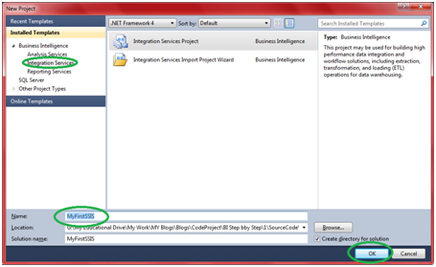

It will open up SSIS designer which you will use for creating and maintaining Integration service packages.

### **Step 2. Create Variable and Assign Value**

2.1 Do either one of these,

* Right click the control flow and select Variables.  
  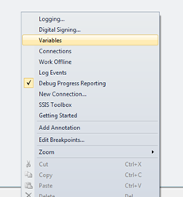
* Click the blue button located in the right-top corner of SSIS designer.

https://www.codeproject.com/KB/database/771871/ssis-designer.png  
It will open up variable window.

2.2 Click on Add Variable button  
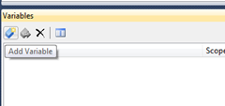

2.3 Define the variable and assign the value.  
https://www.codeproject.com/KB/database/771871/assign-value.png

### **Step 3. Add Script task to control flow**

Take Script task from the toolbox and add it control flow

### **Step 4. Configure script task.**

4.1 Double click the script task. It will open Script task editor.

4.2 Next we have to configure what variable we want to pass to the script. We can pass variable as either read only variable or read write variable. Click the triple dot button in front of either ReadOnlyVariable or ReadWriteVariable.  
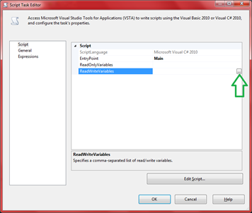  
Select the variables and click OK.  
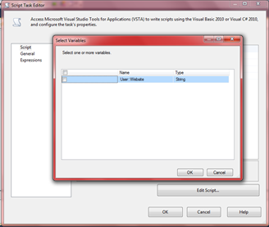

4.3 Next, click on edit script.  
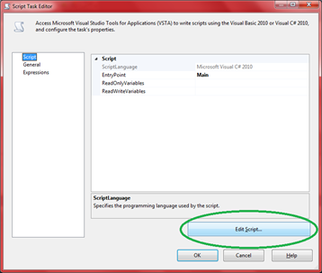  
It will make a new instance of Visual studio open up with a “.cs” extension file.

4.4 In the main Method write the following code.

public void Main()

{

*// TODO: Add your code here*

MessageBox.Show(Dts.Variables["Website"].Value.ToString());

}

4.5 Press Ctrl+Save and save the file.

4.6 Close the Current Visual studio and go back to Sql server data tools where “script task editor” is open.

4.7 Click OK.

### **Step 5. Execute package.**

Press F5 and execute the application.

### **Step 6. Check the output https://www.codeproject.com/KB/database/771871/output.png**